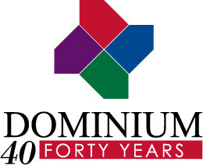 | Media Contact  Josie Hemmingsen  For Dominium  (952) 851-7227  jhemmingsen@tunheim.com
FOR IMMEDIATE RELEASE

Dominium Announces Changes in Ownership Structure
Minneapolis –November, 2012 – Dominium, a leading apartment development and management company, today announced changes to the company’s ownership structure.

Following the passing of Dominium co-founder, David Brierton, Dominium has purchased the ownership interest of both Brierton’s estate and of co-founder Jack Safar. Safar and Brierton’s estate will remain owners in 170 existing partnerships but have sold their interest in any future new developments and business ventures.

“A new generation of ownership has taken the helm at Dominium,” said co-managing partner Paul Sween. “We’re proud to have 40 years of history, built on the solid foundation laid by our founders, and this arrangement will help us stay on track for another 40 years and more.”

Co-managing partners Sween and Armand Brachman also announced that Mark Moorhouse has been named a partner for Dominium Development & Acquisition. Moorhouse has been with Dominium since 1996, working on portfolio acquisitions, new project development, and the acquisition of existing apartment projects. Moorhouse has played an integral role in helping the company grow from managing 6,400 units in 1996 to more than 20,000 units in 21 states.

About Dominium
Founded in 1972, Dominium is a Minneapolis-based owner, developer, and manager of apartment communities nationwide. With more than 23,400 owned and/or managed units at 222 sites in 21 states, for 40 years Dominium has been known for creative solutions to unique and challenging development projects, and management expertise. For more information visit www.dominiumapartments.com.

###

