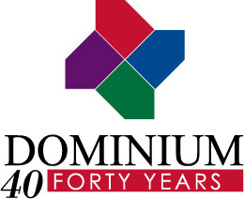
Media Contact:
Owen Truesdell
Tunheim
PH: 952-851-7262
otruesdell@tunheim.com

FOR IMMEDIATE RELEASE

Dominium Among National Affordable Housing Leaders
Affordable Housing Finance Magazine names Minneapolis company fifth largest owner of affordable multi-family housing

MINNEAPOLIS – April 18, 2013 – Dominium, a leading apartment development and management company, has been named the fifth largest owner of multifamily affordable housing in the country by Affordable Housing Finance magazine. With over 23,000 affordable housing units in 22 states, Dominium continues to be a leader in providing high-quality housing across the country.

Dominium’s fifth-place ranking in Affordable Housing Finance magazine’s 2012 list is up three spots from last year, reflecting Dominium’s continued successful expansion in numerous markets across the country.

“We’re very pleased to be among the national leaders in providing access to affordable housing for families in our communities across the country,” said Dominium Senior Vice President Mark Moorhouse. “As Dominium continues to expand around the country, we remain committed to providing the highest-quality tenant experience, as we have for the last 41 years.”

Companies were ranked based on the number of affordable units owned in 2012. More than 100 companies submitted applications for the list, which is published annually.

About Dominium
Founded in 1972, Dominium is a Minneapolis-based owner, developer, and manager of apartment communities nationwide. With more than 23,400 owned and/or managed units at 226 sites in 22 states, for 40 years Dominium has been known for creative solutions to unique and challenging development projects, and management expertise. For more information visit www.dominiumapartments.com.
###

